## Cheyls Galactica

It would be remiss to write a guide to the races of the disc without mentioning the Star turtle. As has been widely accepted since the time of the Prophet Brutha, the world is a disc carried on the back of 4 giant elephants that are in turn standing on the back of the Star turtle Great A’Tuin, himself, or herself, their gender has been the subject of much scholarly debate. At present Great A’Tuin is the only example of Cheyls Galactica that we know of.

## Foreword

For centuries, the holy presses of Omnia have produced this guide penned by the legendary Cut my own hand off Dhabla. A text detailing the various races that the faithful may encounter on the disc and how best to guide them into the light of Om. Now the presses of Teemer and Spoole are proud to present a denominationally neutral edition of the famous guide for the busy traveler.

## Humans

Shorter lived than trolls, and less clever with machinery than dwarves, humanity still manages to form the bulk of the visible population of the Disc. This is simply because human’s breed so well - a survival strategy they share with rodents, cockroaches and bacteria.

Though not a separate race it would be remiss not to mention wizards. Among humans, the eighth son of an eighth son develops the ability to manipulate magic and is often packed off to the Unseen University where they receive tutelage, their wizard staff (with a knob on the end), and an affinity for big dinners.

## Trolls

Ambulatory silicon life forms with all the playful energy of a landslide, trolls largely keep to themselves out in the wilderness. In recent years a great many of these creatures have begun filtering into Ankh-Morpork looking for work.

In the cold air of the mountains trolls are in fact quite bright, almost cunning; only in the warmer lowlands are they a byword for stupidity. In fact the slowness of thought is induced by the effect of heat on the silicon troll brain. If sufficiently deep frozen, a troll is astonishingly intelligent.

Troll cuisine is completely incompatible with most other species, their food largely consisting of assorted metamorphic and igneous rocks and their beer being a caustic chemical cocktail. Likewise, troll fashion is largely limited to the traditional loincloth and belt of human skulls, but in these modern enlightened times, most trolls settle for goat skulls.

There is nothing subtle about trolls. Trollish is a very physical language, where one troll hitting another troll on the head with a rock is about the equivalent of two humans exchanging the time of day. They have thousands of words for different kinds of rock but only one word for plants.

Despite recent international treaties, the well-known animosity between trolls and dwarves continues to persist and will likely do so until the disc stops turning for the simple fact that one race is made of rocks, and the other is made of miners.

## Golems

Enormous men of clay and fire, baked by ancient civilisations and given life by holy words written on their Chem, a scroll of

parchment placed inside their head. A golem is not so much a living creature as a thinking machine, golems live to work, without need for food, rest or leisure, they can work in complete darkness, or waist deep in poison. A golem obeys the words in it’s head to the letter and will not kill or harm a living creature. Golems’ must have a master however in recent years golems have begun to purchase other golems to give ownership to themselves, these so called free golems mostly operate under the Golem Trust organisation who will contract the services of free golems out to potential employers.

## Goblins

Recently declared a sapient species rather than a pest by international treaty the squart, gangly limbed subterranean goblin is becoming a more and more common sight in cities. The story book monster has been replaced by a race known for their superb pottery and affinity for mechanical systems like the clacks systems. There is of course still the smell, which is not exactly bad but is most certainly the smell of goblins, however one does eventually get used to it, eventually.

### Werewolves

Another undead hailing from Ubervald, werewolves are not half-wolf half-human hybrids, but rather a human, with the ability to take wolf form, or sometimes visa versa. Most have control of when they switch forms but the light of a full moon is an irresistible trigger for the transformation. Silver, as folklore suggests, is lethal to werewolves and painful to the touch.

## Igors:

Despite appearances, the igors are not technically undead, rather they are a clan of exceedingly skilled surgeons and man-servants from Ubervald. A igor is easily identified by their lisp, hunchback and appearance that suggests that they were sewn together from several different body parts, this in fact, is the case. Among the clan, body parts are passed down from older relatives to younger ones, when they say an igor has his grandfather’s eyes, they mean it. The female members of the clan, the Ignorinas, are harder to identify save for the telltale lines of stitching they carry. In the old country, igors often serve as loyal man-servants to vampires, werewolves, mad doctors and other castle-owning aristocrats. Outside of the old country, igors are often sought after as assistants by the rich or mechanically inclined, or as surgeons by medical establishments.

## Dwarfs

Dwarfs are approximately four feet tall, stocky, bearded, long-lived and with a natural attraction for mountains and mineshafts.

A flaw in dwarfish nature from a human point of view is their tendency to take things literally. This is a result of their subterranean life. In an environment where there are things always ready to explode or collapse it is vitally important that information be passed on clearly and honestly. The human language, with its unthinking reliance on metaphor and simile, is a veritable minefi..a complete morass..a fog of incomprehesi...very difficult for dwarfs.

Currently the largest dwarf city on the disc is Ankh-morpork, where they are the biggest non-human ethnic group. Usually they fit in well. All dwarfs are by nature dutiful, serious, obedient and thoughtful, and their only failing is a tendency, after one drink, to rush at enemies, screaming “Aaarrgh!” and axing off their legs at the knee.

Dwarfs are famously not religious, as they will tell you. However, there exists a caste of dwarfs known as the Grags, or Deep-downers who are definitely not high priests, serving as experts in dwarf law, funeral rites and arbiters of what is and is not dwarfish. Naturally, other races tend to be unpopular with the Grags, who prefer to deal only with other dwarfs and avoid going above ground whenever possible.

Dwarf bread is a staple of dwarf culture but is not to be mistaken for dwarf cuisine, which primarily consists of rat and ketchup. Dwarf bread is in fact highly inedible and classed as a cultural weapon alongside the traditional dwarf axe.

Dwarfs are by convention, dwarf, with no distinction made between genders once the children are on solid foods. However in recent years there has been an explosion in the dwarf community of dwarfs coming out as openly female, taking more feminin names, swapping chainmail trousers for leather skirts, carrying their battleaxe in a handbag and, in some cases, welding high heels to their iron boots. These openly female dwarves have been met with much beard pulling and harrumphing from some of their more traditionally minded elders, but it seems that they are here to stay.

It is a common misconception that the plural of Dwarf is Dwarves. On the Disc, this is simply not true and the correction pluralisation is Dwarfs.

## The Undead

Those that are differently alive come in many forms, though most, contrary to common folklore, prefer to be left alone to get on with their after-lives. Though the undead can exist anywhere on the disc they are most common in the dark country of Ubervald and the much darker city of Ankh-morpork.

### Zombies

A zombie is merely a person, typically human, for whom Death did not stop. When they died, sheer force of personality or perhaps pure stubbornness took the place of lifeforce and now they continue to afterlive as they did before, asides from a greying of the skin and a tendency for bits to fall off. Flesh-eating does not feature on a zombies itinerary, nor does eating in general, sleep or most bodily functions.

### Vampires

Blood-sucking aristocratic undead from the country of Ubervald, though most have swore off blood-sucking these days. Most of the powers and weaknesses attributed to vampires by folklore hold true, a weakness to being staked in the heart, an aversion to holy symbols, crumpling in the sun, the ability to turn into bats, etc. Though vampires can go out in the sun given a broad-brimmed hat and sufficiently powerful sunscreen. Even if a vampire does crumple due to exposure to sunlight, a drop of animal blood on their ashes is enough to reconstitute them. Most city-dwelling vampires are members of the Ubervald League of Temperance, these so called Black Ribboners have sworn off human blood and take a very dim, and rather permanent, view of any vampire, member or otherwise, that falls off the wagon inside of a city.

### 

## *“Vaguely Useful”* -The Times of Ankh-Morpork

## *“Lacking ‘Orible Murders”* -The Tanty Bugle

## *“There are better uses for a dollar”* -The Merchants Guild of Ankh-Morpork

###### 

###### 

###### 

###### 

###### 

###### 

###### Contents assembled from pieces taken by Owen Ryan from the Discworld CD-Rom manual, the Discworld Wiki, the L-space wiki and patched together with his own writings.

###### Cover Art nicked from Pinterest, original artist unknown but believed to be Steven Player

C.M.O.H.O. Dhabla’s

Guide to the

Races of the Disc

#### Non-Believer’s Edition

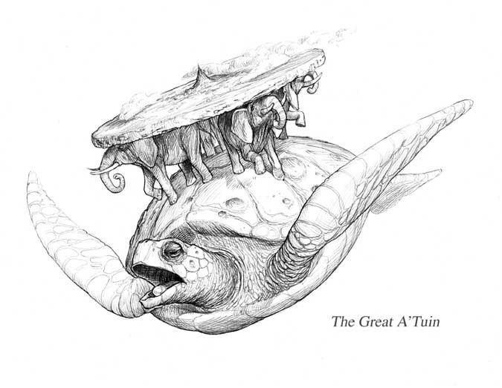

##### Teemer and Spoole Publishing